Задача 2. Оцвети картинката

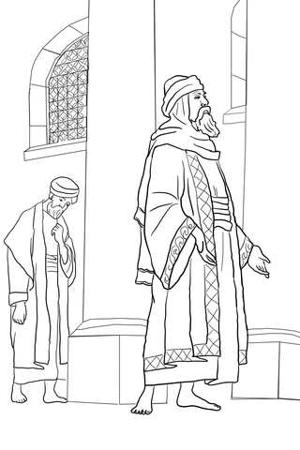

http://www.supercoloring.com/coloring-pages/pharisee-and-the-publican
Author: Nata Silina Permission: This work is licensed under a Creative Commons Attribution-Share Alike 4.0 License.

